what is docker :

Docker is a platform for developing, shipping, and running applications in containers. ​

Container: A container is a lightweight, standalone, and executable software package that includes everything needed to run a piece of software, including the code, runtime, libraries, and system tools. Containers are isolated from each other and from the underlying system, making them portable and consistent across different environments.

Docker Image: A Docker image is a lightweight, standalone, and executable software package that includes everything needed to run a piece of software, including the code, runtime, libraries, and system tools. Docker images are used to create containers. Images are built from a set of instructions, defined in a file called a Dockerfile. Docker images can be versioned, stored, and shared.

Dockerfile: A Dockerfile is a script that contains a set of instructions for building a Docker image. It specifies the base image, sets up the environment, installs dependencies, and defines how the application should run within the container. Dockerfiles are used to automate the process of building Docker images.

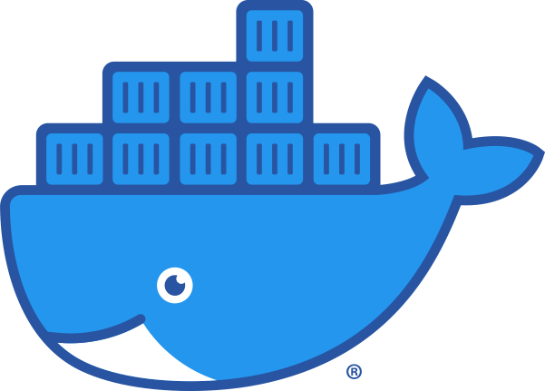

Docker Registry: A Docker registry is a repository for storing and distributing Docker images. It is a central server that stores Docker images, and it can be either public or private. Public registries, such as Docker Hub, allow you to share images with the community, while private registries are used for storing proprietary or sensitive images within an organization. Docker images can be pushed to and pulled from a registry, making it easy to distribute and deploy applications.